CRM DYNAMICS INTRO

CRM(Customer Relationship Management) Systems:
- a system used by businesses to manage interactions with their customers; both current and potential.
- CRM system is a software tool that helps companies store, organize, and analyze customer data in one place, like Contact details, Purchase history and Complaints or support request
- The main goal of CRM is to:
- Improve customer satisfaction
- Increase customer loyalty
- Boost sales and profitability

CRM side of Dynamics 365: instead of a single “CRM” product, you get different CRM apps (modules) such as:
- Dynamics 365 Sales
- Dynamics 365 Customer Service
- Dynamics 365 Marketing

Microsoft Dynamics 365 Sales:
- helps your organization manage the entire sales lifecycle — from identifying a potential customer (lead) to completing a successful sale (invoice).
- Sales processes includes:
- Lead and Qualify: A lead is created when someone shows interest (fills a form, calls, etc.).
  - salesperson reviews the lead’s details — checks if the person is a real potential buyer , If interested → Qualified (moves to the next stage)
  - Dynamics 365 Role: Stores all lead information and allows quick qualification or disqualification.
- Develop: Once a lead is qualified (seems interested and capable of buying), it becomes an opportunity, meaning a potential sale.
  - It links that opportunity to a customer account (company) or contact (person). connects to both so you can track who and what organization the deal is with.
  - Sales reps start developing the relationship; understanding customer needs, products required, budget, etc.
  - Dynamics 365 Role: sales progress, discussions, pricing, and follow-ups.
- Propose: salesperson prepares a Quote — an official offer showing product details, prices, and terms.
  - Customer reviews and either accepts or rejects it.
  - Dynamics 365 Role: Automatically generates quotes, manages multiple versions, and tracks approval.
- Close: Once the quote is accepted, it’s converted into an Order.
  - The company starts fulfilling it — arranging shipment or delivery.
  - Dynamics 365 Role: Creates and tracks sales orders, integrates with inventory or ERP systems to ensure fulfillment.
- Fulfill: After the order is fulfilled (product delivered), an Invoice is generated and sent to the customer .
  - Dynamics 365 Role: Generates invoices, tracks payments, and updates financial records (integrated with Microsoft Finance)
Product lifecycle:

Stage | Description | Example
Create | Add a new product | “Laptop Model X1” at $900
Revise | Update an existing product | Change price to $950
Revert | Undo recent changes | Restore old $900 price
Clone | Duplicate an existing product | Copy X1 → “Laptop Model X2”
Retire | Remove from active sale | Stop selling X1

A company creates a Laptop Model X1, revises it to update specs, reverts a pricing mistake, clones it to create Model X2, and finally retires X1 when the new model replaces it.

Goals: targets or performance metrics used to measure how well salespeople or teams are performing; like sales quotas (e.g., sell $50,000 this quarter).

Term | Meaning | Example
New Goal | A specific target you create in the system. | “Sell 100 laptops in Q1”
Parent Goal | A higher-level goal that groups smaller (child) goals. | “Increase total electronics sales” (parent of laptop, tablet goals)
Goal Name | The title or label of the goal. | “Laptop Sales Q1”
Goal Metric | What you’re measuring — sales revenue, number of deals, etc. | “Revenue” or “Units Sold”
Goal Owner | The person responsible for achieving the goal. | “Ali Khan – Sales Rep”
Manager | The supervisor who reviews progress and manages owners’ goals. | “Sara Ahmed – Sales Manager”

Analytical options in Sales Dashboard:
- Interactive Charts: You can click parts of charts (e.g., a bar in a sales graph) to filter or drill down into specific data.
- Views: Display lists of records (like leads, opportunities, or accounts) that can be sorted, filtered, or searched directly from the dashboard

Sales Order Processing:
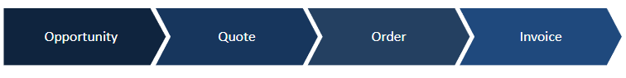

Microsoft Dynamics 365 Marketing:
main components of Dynamics 365 Marketing:
- Real-time Marketing: Instantly reacts to customer actions and personalizes engagement.
Feature | Example
Respond to customer actions in real time | A customer clicks on a product link in an email — Dynamics 365 immediately sends them a discount offer for that product.
Hyper-personalize your messaging | The system sends a birthday email to a customer using their name and suggesting products based on past purchases.
Connect with customers on their preferred channels | If a customer usually interacts via WhatsApp, the follow-up message is sent through WhatsApp instead of email.

- Outbound Marketing: reaches out to potential customers through campaigns.
  - Create campaigns to turn potential customers (prospects) into leads.
  - Leverage the power of social media: A marketing team schedules and tracks posts on LinkedIn and Facebook directly from Dynamics 365 to attract potential clients.
- Event Planning: Organizes and manages marketing events and follow-ups.
  - Manage all event needs in one place: A company creates a webinar event in Dynamics 365; it manages registration forms, invites, reminders, and attendance tracking all from one dashboard.
  - Meet your audience where they are: Customers can join an online event from their preferred platform, like Teams or Zoom, directly via the invite link
  - Continue the conversation with webinar participants: After the webinar, Dynamics 365 automatically sends thank-you emails with related resources and a “Book a Demo” link.

Account-Based Marketing (ABM): targeted marketing strategy where instead of focusing on many individual customers, you focus on specific high-value accounts (companies).
- If Microsoft is your client, Microsoft is the account, while its employees like John (IT Manager) or Sara (Procurement Officer) are contacts under that account.

How 365 Marketing Helps:
- Account-based Journeys: Automated campaigns built around an account (company).
  - Helps generate leads, send targeted messages, and assign related activities (like meetings or follow-ups).
  - Example: A software company creates a journey for Microsoft; sending emails to its IT team, scheduling demos, and assigning the sales rep to follow up, all part of one automated journey linked to that account.
- Account-based Personalization of Email Content: Email content is customized using data from the account record.
- Account-based Leads and Lead Scoring: Generates and tracks leads tied to a specific account and assigns a score to measure how close the account is to buying; based on combined activity from all its contacts.

Capture leads generated on LinkedIn: LinkedIn Lead Gen (Lead Generation) is a tool in LinkedIn Ads that allows businesses to collect contact information from people directly through LinkedIn forms; without the person leaving LinkedIn.
- Example: A user sees an ad for a free product demo, clicks it, and a pre-filled form appears with their LinkedIn info (like name, job title, company, and email). When they submit it, that’s a lead
- Dynamics 365 Role: automatically bring those LinkedIn leads into Marketing
  - If that person already exists in your CRM, it updates their record.
  - If they’re new, it creates a new lead record in Dynamics 365.

Segment Types:
- Static Segment: fixed list of contacts that you manually choose
  - members stay the same until you add or remove them yourself; the system doesn’t change it automatically.
  - Used when you want to target a specific known group of people (e.g. VIP customers you know personally or one-time campaigns)
- Dynamic Segment: A smart, auto-updating list that is built using rules or conditions (logical expressions). Contacts automatically join or leave the segment based on their data or behavior.
  - Useful for ongoing campaigns like newsletters or promotions.
  - E.g. Rule: Include all contacts from “Karachi” who opened an email in the last 30 days.

Customer Journeys and Flows: automated marketing process that guides customers (contacts) through a series of steps or actions based on their behaviour.
Flow: sequence of steps in the journey what happens next depending on each customer’s action.

- Outbound Journey: You reach out to customers
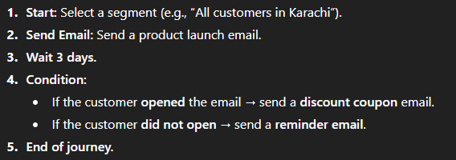
- Inbound Journey: Customer Acts first (is the trigger)
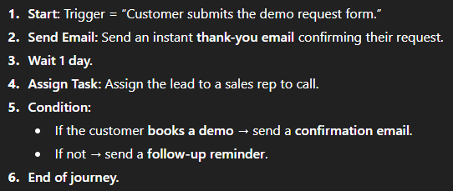
Can use this for LinkedIn Form Submissions

Event website: is a web portal automatically created and managed through Dynamics 365 Marketing to handle all event-related activities online, and can be fully-customized according to your brand
- public-facing site where people can view, register for, and get details about your events.
- All attendee information (attendance, cancellation, registration) is managed and tracked by 365

Microsoft Dynamics 365 Customer Engagement:

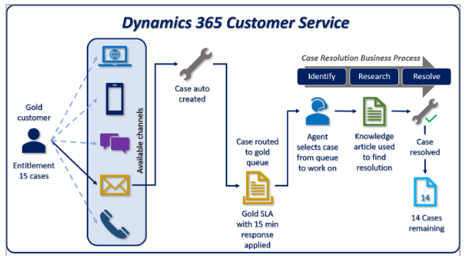
- The Gold Customer has a service entitlement of 15 cases; meaning they can get support for up to 15 issues.
- Available Channels: Customers can raise support incidents through multiple channels, such as email, phone.
- Case Auto-Created: Dynamics 365 automatically creates a new case record from the customer’s message.
  - Example: The system detects the email and creates a case titled “Login issue – Unable to access dashboard.”
- Case Routed to Gold Queue: which prioritizes premium clients, ensures their request jumps ahead of standard customers.
- SLA (Service Level Agreement) Applied: system applies a 15-minute response SLA, meaning an agent must respond within 15 minutes, clock ticks the moment case enters queue
- Agent Work: picks up the case from the Gold queue and starts investigating
- Internal Knowledge Base Used: refers to a repository of Knowledge Article to find the correct solution.
- Case Resolution: issue is resolved, and the system automatically updates the entitlement balance of the customer (now 14)

Asset: physical item or product located at the customer’s site on which the service is performed, e.g air conditioner is the asset recorded in the system.
- Service cases, maintenance history, and warranties are all linked to that asset.

Case Hierarchies:
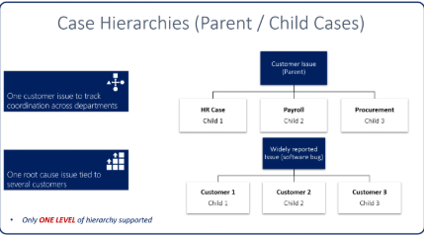

- Departmental Coordination: A customer reports an issue — “Payroll data is not updating correctly.”This issue affects multiple departments
  - The parent case tracks the overall customer problem, while child cases let each department handle its part independently.
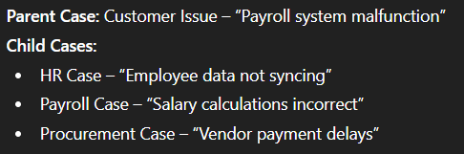

Entitlement Lifecycle:
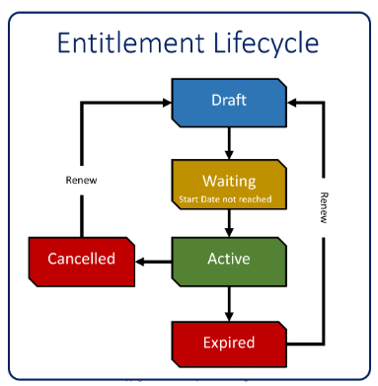

- Draft: The entitlement is being created but not yet active.
  - Example: You create a new “1-Year Premium Support” entitlement for a customer, but it’s still under review.
- Waiting: The entitlement has been approved but the start date hasn’t begun yet.
- Active: The entitlement is currently valid and can be used.
  - Example: The customer’s 1-Year Support Plan is now active, allowing them to open support cases.
- Expired: The entitlement’s end date has passed; it’s no longer valid.
- Cancelled: The entitlement is manually stopped before its end date.
  - Example: The customer cancels their support plan halfway through the year.
- Renew: You can renew an entitlement from Expired or Cancelled back to Draft to restart or extend it.

Microsoft Dynamics 365 Field Service:

Primary Field Service Flow:


- Work Order Generation: Define what needs to be done.
  - How created: Manually by customer service agents or automatically from a case
  - Information entered: Customer details, service location, issue type, priority, required products/skills
  - When ready to schedule: Once all needed info (e.g., customer approval, resource requirements) is completed.

- Schedule & Dispatch: Assign the right technician at the right time.
  - Can be done manually (dispatcher assigns), semi-automated (dispatcher approves suggestions), or automated (auto-dispatch by system)

- Service Delivery: Technician performs the on-site job.
  - Technician accesses: Job details, customer history, parts required via the Field Service Mobile App.
  - Information entered: Work performed, parts used, photos, customer signature, and completion notes.
- Review & Billing: Finalize and close the process.
  - Follow-up work: If the repair is incomplete, another work order is generated.
  - Billing & adjustments: Labor and parts are billed; inventory is updated automatically.

Work Order Lifecycle:
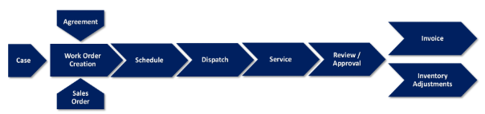

- Work Order Creation: Sources:
  - A Case (customer complaint or service request)
  - An Agreement (e.g., scheduled maintenance contract)
  - A Sales Order (installation service after product sale)
- Schedule: Assign time and technician.
  - The system assigns Ali, available tomorrow at 9 AM, for this job (manually or auto-scheduling)
- Dispatch:
  - Send job details to the technician’s Field Service Mobile App. The technician sees location, issue description, and parts needed.

- Service: Technician performs the work.
  - He records activities, parts used, labor time, and collects customer signatures upon completion.
- Review / Approval
  - The supervisor or dispatcher checks the completed work for accuracy, using the information entered by the technician
- Inventory Adjustments:
  - Update stock for parts used during service.
- Invoice
  - Generate billing for customers Includes labor, parts, and service fees.

Work Order Related Records:
The Work Order is the main record — it defines what service needs to be done, where, and by whom. All other records either support or are linked to this.

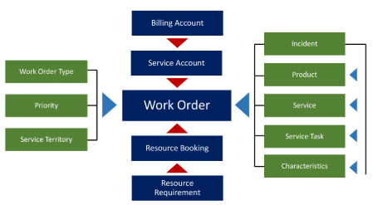
Left: kind of work it is and where it belongs.
- Work Order Type: Categorizes the job (e.g., Installation, Maintenance, Repair).
- Priority: Defines urgency (High, Normal, Low).
- Service Territory: Defines the region or area where the job will be performed.

Top:
- Billing Account: The customer who receives the invoice.
- Service Account: The physical location or branch where the service happens.

Bottom:
- Resource Requirement: Specifies the needed technician skills or tools.
- Resource Booking: Actual assignment of a technician with time and date

Right:
- Incident: A reported issue that triggered the work order.
- Product: The item or equipment related to the job, e.g. LG 2-ton Split AC
- Service: The type of service task (Repair, Installation, Inspection).
- Service Task: Specific job steps within the work order. Check gas level → Replace compressor
- Characteristics: Required technician skills or attributes.

Canvas App

Canvas Apps – allows users to design highly customized UI by dragging and dropping controls on a canvas

Key Characteristics of Canvas App:
- UI-first approach, focuses on user experience rather than data structure
- Full control over layout, colors, and positioning of UI elements
- Uses Power Fx, a low-code formula language
- Supports responsive design for different screen sizes

Canvas Apps can connect to various data sources, including:
- Dataverse
- Sharepoint
- Excel
- SQL Server
- Third-party connectors (APIs)

This flexibility allows Canvas Apps to act as an integration point between systems

Limitations:
- Not ideal for complex data-driven processes
- Logic complexity can increase maintenance effort
- Performance depends on data source optimization

Model Driven App

Model-Driven Apps – applications built on top of a Dataverse model, so the UI is automatically generated based on the data structure, relationships and business rules

Key Characteristics:
- Data-first approach
- Uses only Dataverse as its data source, having no alternative
- Uses forms, views, dashboards, BPFs
- Uses Dataverse security roles, providing a role-based UI
- MDA sharing is done via security roles, not individual sharing (assign security roles to users or teams and publish the app)

Core Components of MDA:
- Dataverse Tables/Entities – stores structured business data such as accounts, contacts, leads etc.
- Forms – defines how data is displayed and edited. This includes sections, tabs and fields
- Views – defines how records are listed and filtered for users
- Charts & Dashboards – provides visual insights and analytics of business data directly within the app
- Business Process Flows (BPFs) – guides users through standardized business process within the app

How does MDA work?
- Using Dataverse schema to generate UI automatically
- Applying security roles to control access
- Enforcing business rules and process flows
- Providing responsive layouts

Limitations:
- Limited control over UI
- Less flexibility in custom design
- Depends heavily on Dataverse licensing

Sitemap – defines the navigation menu of the MDA. It controls the areas, group, and sub-areas
Example:
Area (e.g., Sales)
└─ Group (e.g., Opportunities Management)
├─ Subarea (e.g., Active Opportunities table)
├─ Subarea (e.g., Closed Opportunities dashboard)
└─ Group (e.g., Accounts & Contacts)
├─ Subarea (e.g., Accounts table)
├─ Subarea (e.g., Contacts table)

Connector – bridges an app (Power App) and flow (Power Automate) talk to a data source. It defines how Power Apps connect, authenticates, reads, and writes data.

Custom Connector – lets you connect your app to any API (can be any personal or public API)

Dataverse – Microsoft’s native data source for Power Platform. It is a tabular data source.

Key Characteristics of Dataverse:
- Has a built-in connector, tight integration with D365
- Uses a common data model shared across Dynamics365 and Power Platform apps
- Uses security roles to allow role-based security to protect sensitive data
- Provides a centralized data storage
- Handles small apps and large enterprise systems efficiently
- Allows implementation of server-side logic, setting default values or provide validation logic

Duplicate Detection Rules (DDR) – built-in Dataverse rules to identify and prevent duplicate records based on a defined matching criteria
It ensures data consistency during record creation, record update, and bulk import.
Example: if two Contacts have same email and phone number → System detects a duplicate

Characteristics:
- Rules are created per table (e.g. Contact, Account)
- Can be applied to multiple fields
- DDR works within the same table, not across multiple tables
- If a duplicate record is found, a warning message is shown. The user can choose to ignore it and continue saving, hence it does not automatically block.

Reports – identifies existing duplicate records and analyzes them
It helps clean existing records, not prevent new duplicates.

Bulk Delete – removes duplicate records in bulk.

Identify duplicates using reports, then using bulk delete to remove them all or selected ones.

Auditing – tracks record creation, updating and deletion.
It helps identify who created duplicates and when changes happened

Audit logs are read-only, and includes:
- Field changes
- Old vs new values
- User who made changes
- Timestamp

OOB Validation – built-in Dataverse rules that validate data during record creation or updation. It:
- Prevents saving a record if required field is empty
- Ensures data matches the column type
- Enforces minimum/maximum limits (string length, range etc.)
- Duplication Detection Rules (DDR)
- Business Rules

Dashboards

Dashboards – provides visual representation of business data in apps

Components of Dashboard:
- Grids (Lists) – displays a view (list of records) from Dataverse
- Charts – represents aggregated data (counts, sums, averages). Common types of bar, column, pie charts.
- iFrames – embeds external web content into a dashboard
- Web Resources – custom UI elements. Example: custom HTML KPI panel created using JavaScript

Types of Dashboards:
- System Dashboards – created by administrators, available to users based on security roles and used for organization-wide insights
- Personal Dashboards – created by individual users, visible only to the creator and can be shared manually.
Example: a sales rep creates a personal dashboard showing only their own leads

If a user can see a dashboard, it does not mean that they can see the entire data inside it.
The data visibility inside of it depends upon its access level and the security role assigned to it.

Business Process Flow

Business Process Flow – guides users through a set of stages to complete a business process.
It is a “chevron bar” you see at the top of a record (like a Sales Lead).
They ensure process consistency.

Key Components of Business Process Flow:
- Stages – broken-down phases of a business process corresponding to something meaningful
- Steps – individual fields within a stage that the user must complete. These are often required, and must be filled before moving on to the next stage.
- Entities (Tables) – BPF spans multiple entities allowing data to flow across related records

Action Step – predefined process (flow or custom action) triggered from BPF without leaving the form.
Example: In Vendor Order BPF, after entering all details, the system ‘notifies the warehouse’ automatically.

How does BPF work?
When BPF is activated:
- It appears at the top of the form like a visual progress bar
- Users complete steps within each stage
- Once required steps are completed, users can move onto the next stage
- Current stage is saved with the record, allowing progress tracking

Types of BPF:
- Linear BPF – follows a straight path from first to last stage. Useful for simple, predictable processes
- Branching BPF – allows different paths based on conditions

Access to a BPF is controlled through security roles.
If a user does not have permissions for an entity or field in the BPF, they cannot interact with it, ensuring that business processes respect organizational security rules.

Limitations of BPF:
- Not designed for complex automation logic
- Depend on correct entity relationships
- Excessive stages can make process confusing for users

Security Roles
Security Roles – controls what users can do and see within the system, defining permissions for accessing data, performing actions, and using features.

The main purposes of security role includes:
- Ensuring users have appropriate access based on their organisational role
- Protecting sensitive business data
- Supporting separation of duties, allowing different users handle different parts of a business process
- Enabling scalable security management as the organization grows

Dynamics365 uses Role-Based Access Control (RBAC) which means that permissions are assigned to roles rather than individual users.
A user can be assigned to one or more security roles.
Key characteristics of RBAC in Dynamics365:
- A user’s effective permissions are combined permissions of all assigned roles
- Roles are defined once and then reused across multiple users
- RBAC simplifies security administration and reduces configuration errors

A security role is composed of multiple privilege sets, each controlling access to a specific resource or capability.

Privileges – define actions user can perform (create, read, write, delete, append, append to, assign, share)

Access Levels – defines how much data a user can access.
Dynamics365 has the following access levels:
- None – no access to data
- User (Basic) – access only to records owned by the user. Example: sales representative can view and edit only their own leads
- Business Unit – access to records owned by users in the same business unit. Example: sales team members can see all leads within the Sales business unit
- Parent: Child Business Units – access to records in the user's business unit and its child units. Example: a regional manager can see data from Sales Karachi BU and Sales Lahore BU.
- Organization – full access to all records in organization. Example: a system administrator can view and manage all customer records in Dynamics 365

NOTE:
- Dynamics work on cumulative roles, if a user has role A and his team has role B, then user has both roles A and B
- If the roles are conflicting, like role A gives read-write access while B gives read-only, then Dataverse security works on maximum privilege wins, hence user will have both read and write access.
- Therefore:
- Roles can only increase access, never reduce it.
- To limit access, you remove the role entirely or use business units / hierarchy / sharing
- There is only ONE organization per environment. All data and all BUs exist within this one organization

Example: Implementing a security role in Dynamics 365
Scenario: A company uses Dynamics365 Sales, with two BUs: Sales & Marketing. The requirement is:
- Sales Executives should work only on Sales data
- Sales Manager should see all Sales team data

Role 1: Sales Executive Role
- On Lead and Opportunity entity:
- Create → User Level
- Read → User Level
- Write → User Level
- Delete → None
- Sales Executive can create and update his/her own Leads and Opportunities, but cannot view other Leads and Opportunities created by other sales executives

Role 2: Sales Manager Role
- On Lead and Opportunity entities:
- Create → Business Unit level
- Read → Parent–Child Business Unit level
- Write → Business Unit level
- Delete → Business Unit level
- Sales Manager can view all Leads and Opportunities created by all Sales users, but still cannot view any Marketing BU data

Types of Security Roles:
- System-Defined (Out-of-the-box) Roles – default roles provided by Microsoft. These cannot be deleted but can be copied & customized.
- Custom Security Roles – created after copying and modifying existing roles to meet specific business needs

Business Unit – logical organizational structure used to group users, data, and processes within an organization.
Example: TechNova Ltd. uses Dynamics 365 Sales and has two departments: Sales Department and Marketing Department.
So, TechNova Ltd. becomes the Root Business Unit (BU), while Sales BU and Marketing BU become the child units

Security Roles are assigned per business unit, meaning the same role can behave differently depending on where it is assigned.
If the user has no privilege in the role, they will have no access even if the record is in their BU.

Example Scenario 1: TechNova Ltd. has two business units: Sales and Marketing
User Setup:
- Ali is assigned to the Sales BU
- Ali is given a security role with Read = Business Unit level on Leads
Result:
- Ali can read leads owned by Sales BU users
- Ali cannot read leads owned by Marketing BU users
Example Scenario 2: TechNova Ltd. has two business units: Sales and Marketing
User Setup:
- Ahmed is in the Head Office BU (Parent BU)
- Ahmed’s security role has Read = Parent–Child BU level
Result:
- Ahmed can see records from Head Office BU, Sales BU, and Marketing BU

Field-level Security – controls access to specific fields (columns) within an entity. It is used for sensitive data, even when the users can access the records itself.

How is it done?
- Fields are marked as field-security enabled
- A Field Security Profile is created
- The profile is assigned to users or teams
- The profile defines whether user can Read, Create or Update field

Example:
- Salary field in the Employee entity is secured
- HR Manager Profile can read and update the Salary field
- Regular Employee Profile cannot see or update the Salary field, even if they can open the record

Hierarchy Security – enables access based on position-based hierarchies, allowing managers to access records owned by their subordinates and extends visibility based on reporting relationships

Types of Hierarchy Security:
- Manager Hierarchy – based on Manager field in Users entity
- Position Hierarchy – based on job positions (e.g. Manager → Supervisor → Employee)

How it works
- Hierarchy security is enabled at the organization level.
- Users higher in the hierarchy automatically gain access to subordinate records.
- It works in addition to security roles, not in replacement of it.
Example:
- Ahmed is Ali’s manager
- Therefore, he can view Ali’s opportunities without record sharing

Teams – collection of users used to simplify security and collaboration.
Teams can own records, be assigned security roles, and be granted access to shared records.

Types of Teams:
- Owner Teams – owns records. Example: Sales Team owns all Sales opportunities
- Access Teams – cannot own records, but they provide temporary or record-specific access. Example: a project record is shared with a temporary project team

Power Automate

Power Automate – low-code automation tool that allows users to create automated workflows between apps and services
It automates repetitive and manual tasks.

Key Components of Power Automate:
- Flows – automated workflow that performs actions based on certain conditions or triggers. They can run in the background (asynchronous) or in real-time (synchronous).
- Triggers – specifies the event that starts a flow. Common triggers include:
- When a record is created or updated in Dataverse
- When an email is received
- When a scheduled time is reached
- Actions – steps performed after trigger fires. Examples include:
- Sending an email or notification
- Creating or updating a record
- Approving a request
- Conditions – enable flows to take a different paths based on logical rules, allowing decision-making within a flow

Types of Power Automate Flows:
- Automated Flow – run automatically when an event occurs. Example: new record created
- Instant Flow – triggered manually by a user, often through a button
- Scheduled Flow – runs at a specific time, or on a recurring schedule
- Business Process Flow – automates an actions when a BPF stage is completed

Power Automates integrates deeply with Dataverse via Connectors
- It can create, read, update, and delete records
- It respects security roles and permissions
- It ensures data consistency across connected system

Connectors – allow Power Automate to talk to data sources and services

Copilot

Copilot – uses generative AI and Natural Language Processing (NLP) to make interactions more human-like.
It enables users to:
- ask questions
- generate content
- call power automate flows
- create chatbots
- read/write data from dataverse

Copilot allows you to add AI to your apps (Power Apps) and flows (Power Automate).
You can either use pre-built or custom AI models.

Key Components of a Copilot Chatbot:
- Topics – define what the chatbot talks about. Each topic handles one task or issue, and is triggered by what the user says
- Triggering Phrases – words or phrases that tell the agent which topic to start. Example:
- “Who are the event contacts?”, “Event Contact Information”, copilot matches these trigger phrases and starts the ‘Event Contacts’ topic
- Nodes – defines the conversation flow. This includes:
- Message Nodes (sends information)
- Question Nodes (asks user input)
- Condition Nodes (decision-making)
- Action Nodes (call Power Automate flows)
- Entities & Variables – entities extract meaningful data from user input, variables temporarily store user response during conversation

Copilot respects Dataverse Security roles, ensuring users only access data authorized to them

Ways in which Copilot Chatbot is used:
- Simple, Static Response Agent
Static here means that the agent does not ask questions, store input nor branch logic.
It just recognizes the phrase, throws the hardcoded response, and ends the conversation.
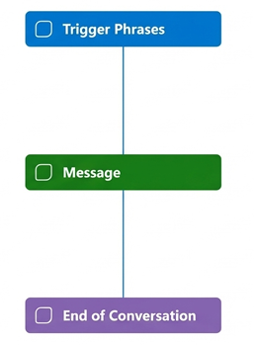
It just comprises of two nodes:
- Trigger Phrase – entry point
- Show a Message – static response, and then the conversation ends
The problem is that the response is not personalized, making the AI agent insufficient and not a true AI-driven agent

- Adding Intelligence, moving from Static Response to Dynamic Conversation
Here, the agent asks the user a question, understands the user’s answer, and responds accordingly.
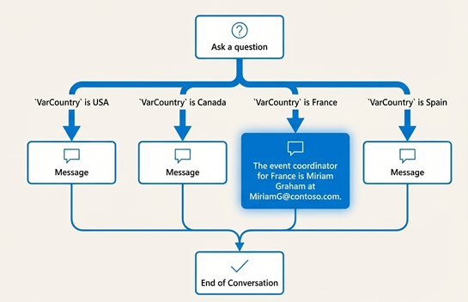
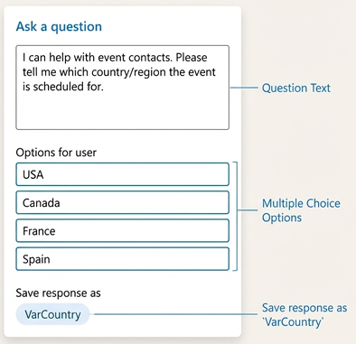

Components:
- Inputs – user responses are collected via “Ask a question” node (can be either text or choice response)
- Variables – temporarily stores user response for further use
- Conditions – creates different conversation path based on variable values
- Copilot automatically creates condition branches for multiple choice option

- Utilizing External Data
Here, the agent interacts with an external data source (usually Dataverse) as it allows scalability and is an enterprise-practice.
This is done via Power Automate as Copilot cannot connect to Dataverse directly as it is a conversion engine, and does not have the connectors to Dataverse.
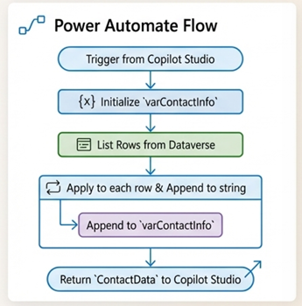
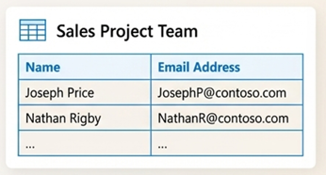

- Supercharging with Generative AI
Copilot Studio allows the agent to make use of Generative Answers as a fallback, when users' query can't be matched to a topic.
It uses AI to generate responses from your specified knowledge sources, eliminating the need to create topics for everything.
Copilot also allows you to supply your own data like documents in the dataverse to ground the AI answers to provide relevant answers

